Frequently asked questions about bank statements:
What kind of bank documents qualify?
-We need to have your most recent bank STATEMENT (not transaction history). It must show the amount that you need to prove.
Here is what a bank statement looks like:
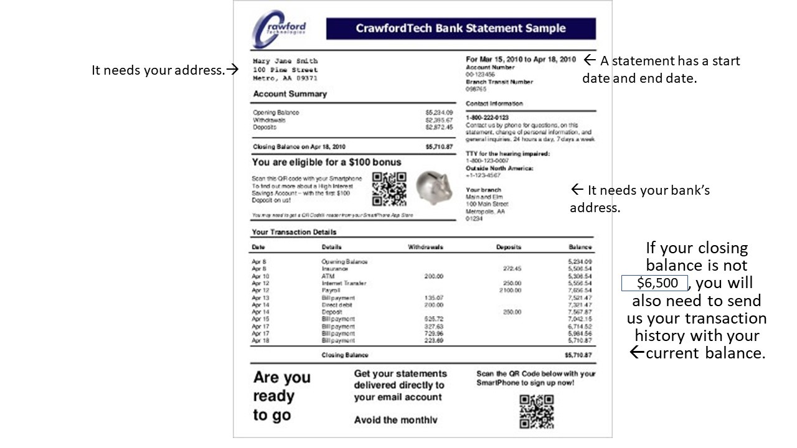
***If your most recent bank statement doesn’t have enough money, but your current account balance does, send us BOTH your most recent BANK STATEMENT and your TRANSACTION HISTORY.
How much do I need to prove?
Single: $6500.00 USD or the equivalent for 3 months (multiply this amount if you want to stay for 6, 9 or 12 months)
Married: Add $1800 for each 3 months you apply for.
Children 11 and over: Add $1800 for each child for each 3 month period.
Children 10 and under: Add $900 for each child for each 3 month period.

What kind of documents does my sponsor need?
Your sponsor (in the United States or in your country) needs to send us:
1. A notarized financial guarantee statement. Ask your bank to notarize this document.
2. His/her most recent bank statement. (We need to have original documents in a sealed envelope from your sponsor's banking institution OR electronic documents that are sent directly from your sponsor's institution.) These documents may be brought in to the office if the sponsor is in the United States.
3. A picture ID of your sponsor.
***If you are sending these documents from overseas, it is important that the documents are sealed in an envelope and they are sent directly to Tampa Language Center from your sponsor’s bank.

What kind of accounts can I use to prove the amount of money I need to show?
The account must be LIQUID. A liquid account means that you can turn the account to cash very quickly without any penalties. Ask your bank if your money is liquid if you are not sure.

